# Laboratory Tasks

**[Task 1]**

In Weka, load the data set ‘soybean.arff’. Perform classifications using the following methods;

1. NaiveBayes (simple Naïve Bayes algorithm)

Using Cross-validation folds = 10

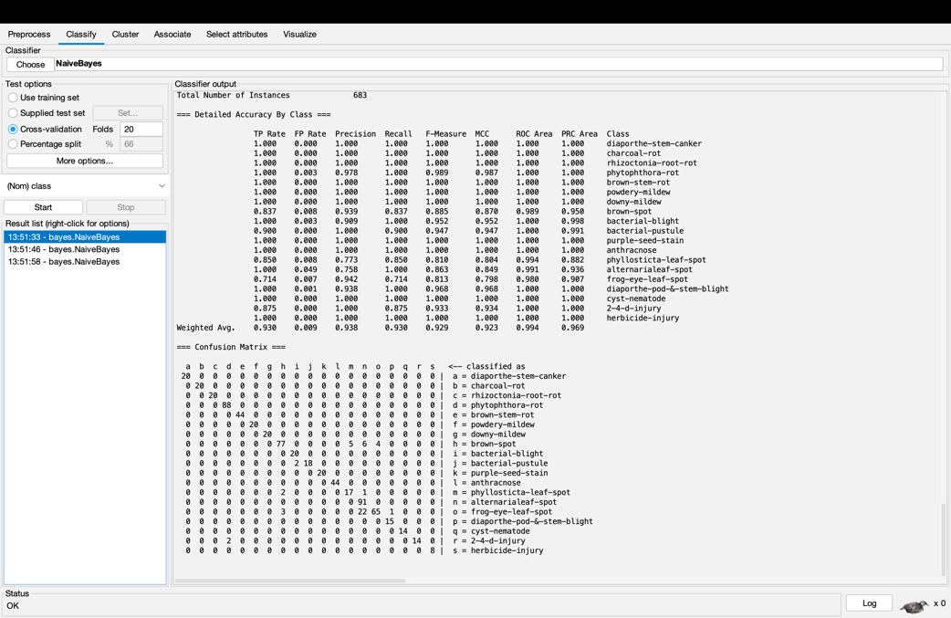

Using Cross-validation folds = 5

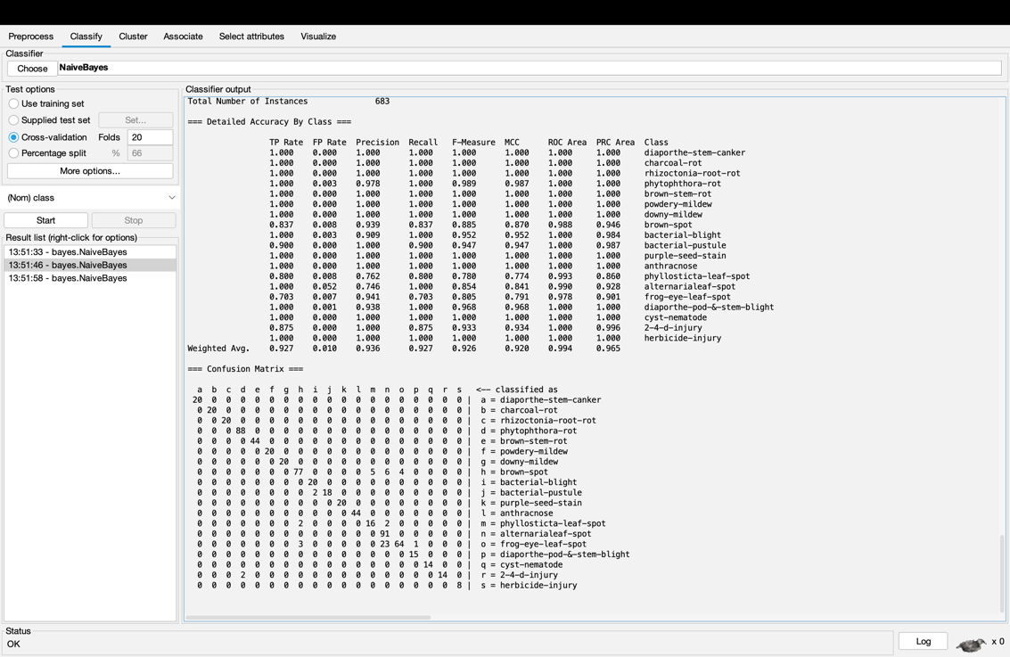

Using Cross-validation folds = 20

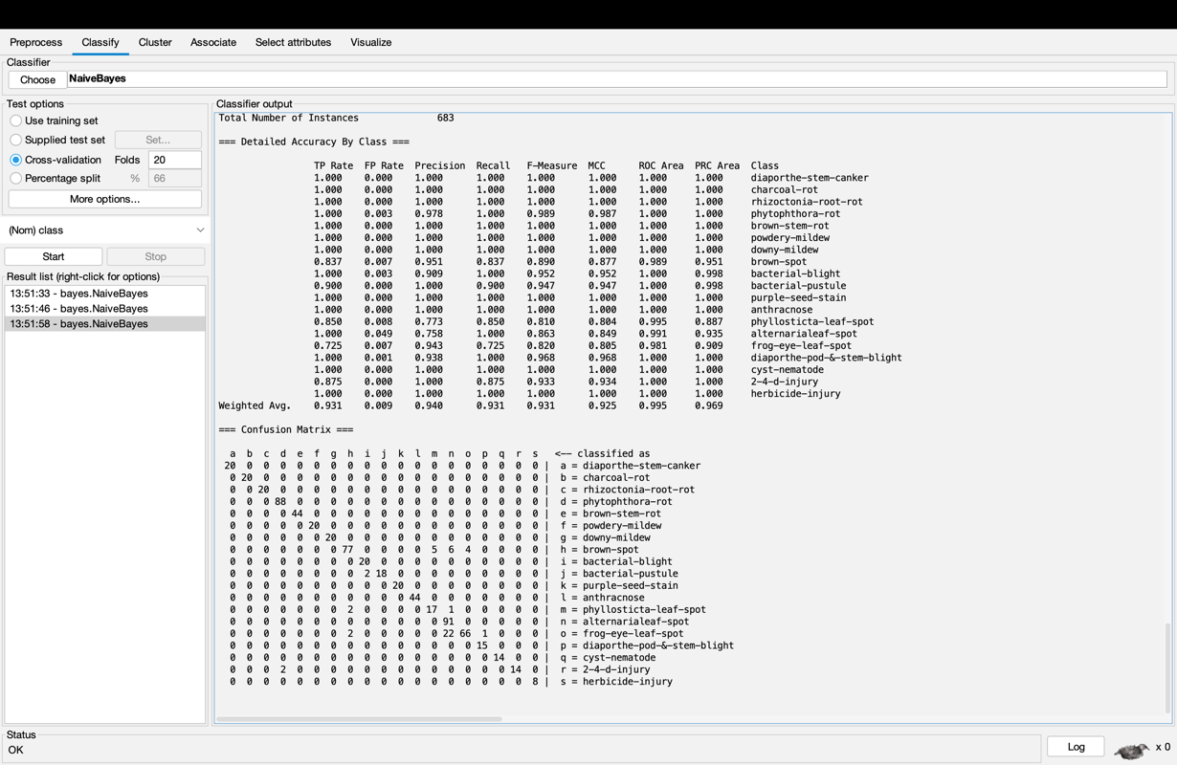

Using Training set

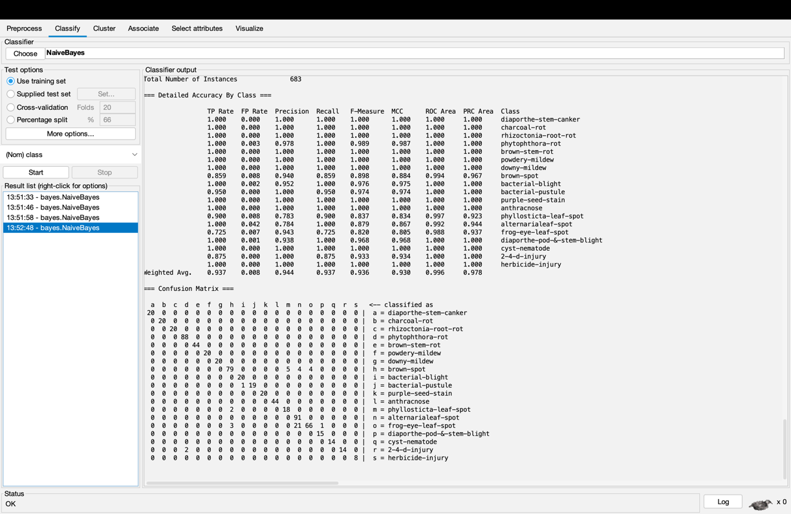

1. IBk (with different k values)

IBk with distance Function of nearestNeighbourSearchAlgorithm = Euclidean Distance

IBk with k-value = 1

Using Cross-validation folds = 10

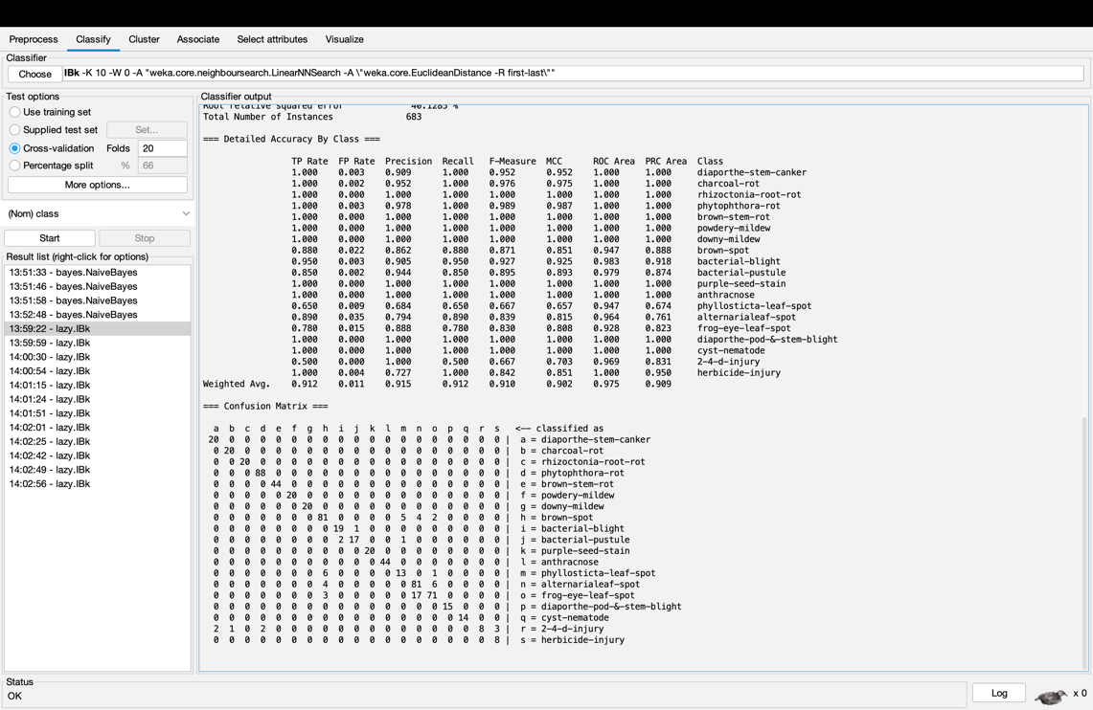

Using Cross-validation folds = 5

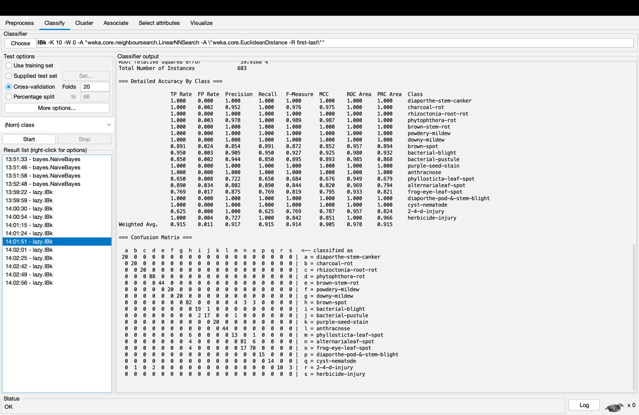

Using Cross-validation folds = 20

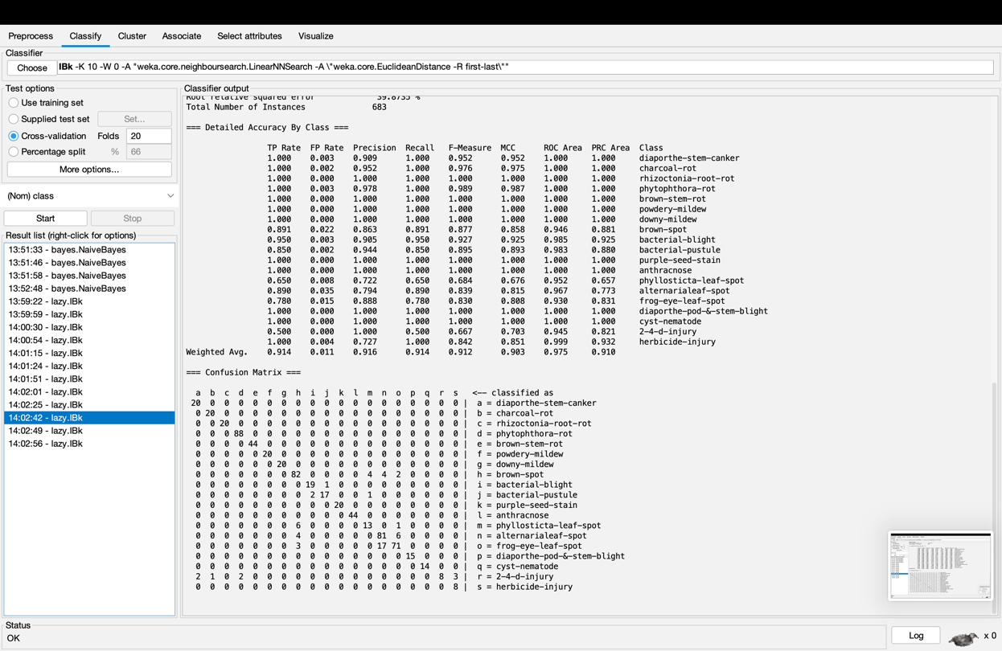

Using training set

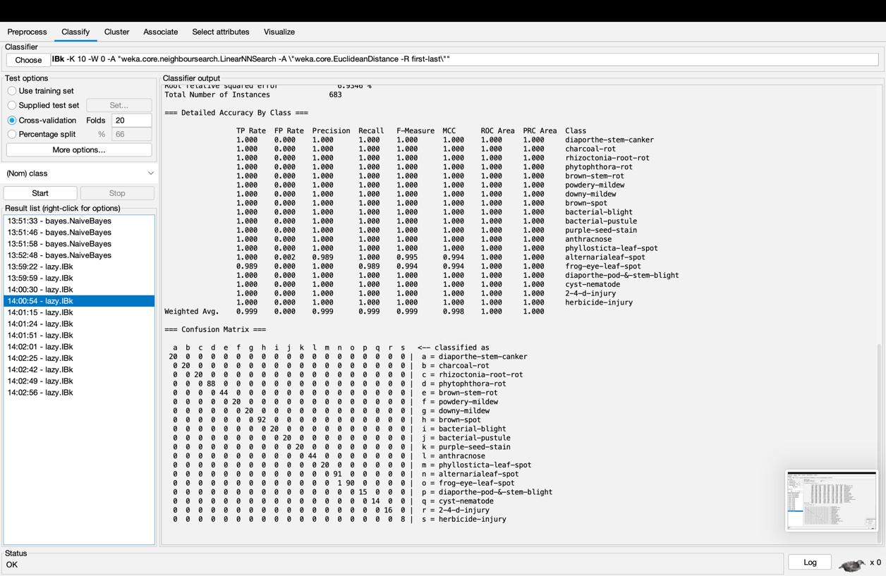

IBk with k-value = 5

Using Cross-validation folds = 10

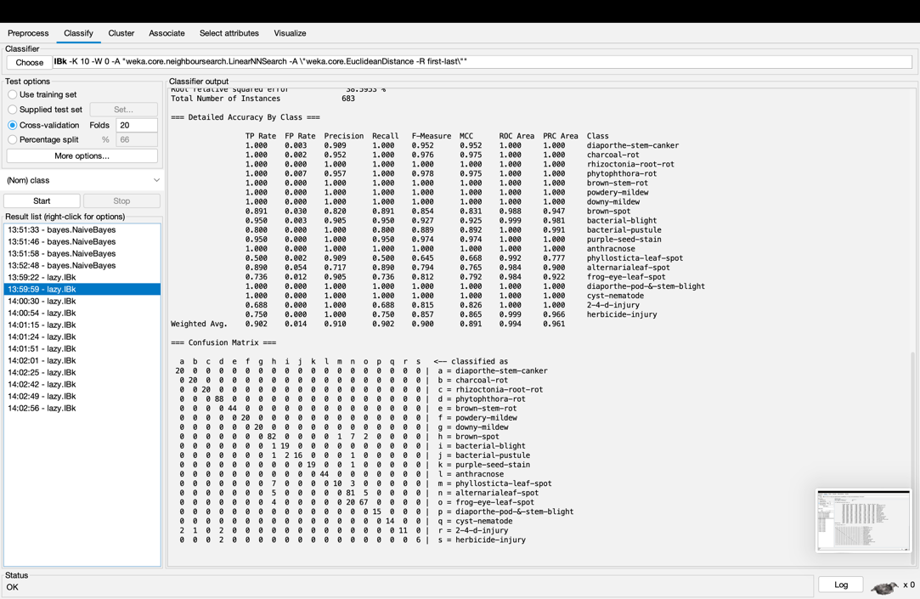

Using Cross-validation folds = 5

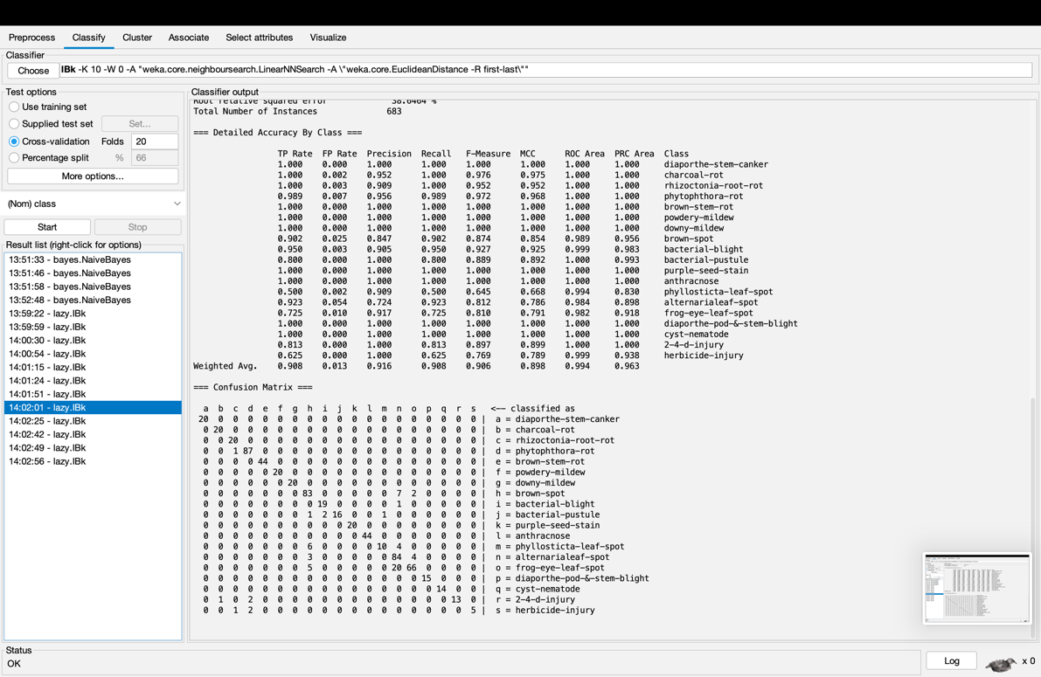

Using Cross-validation folds = 20

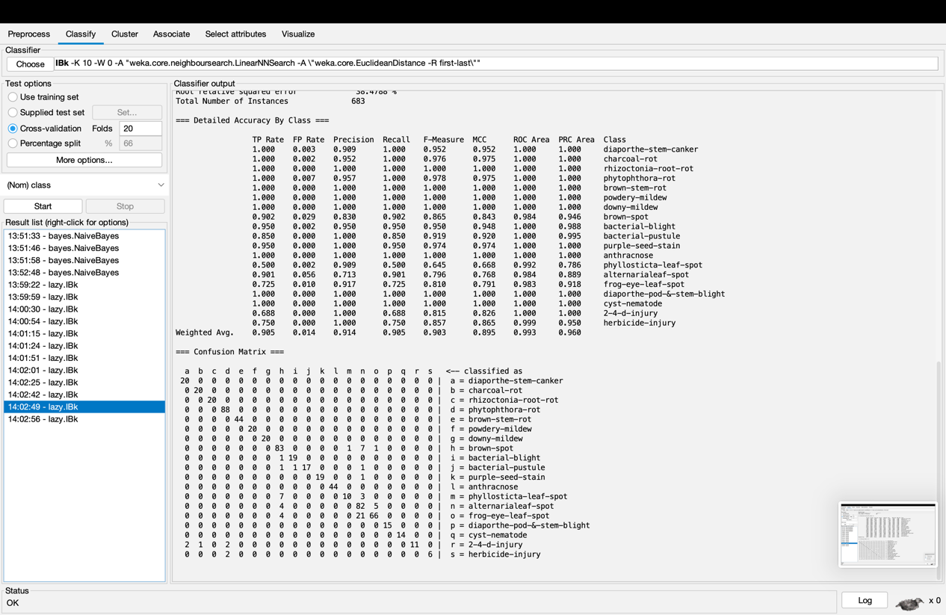

Using training set

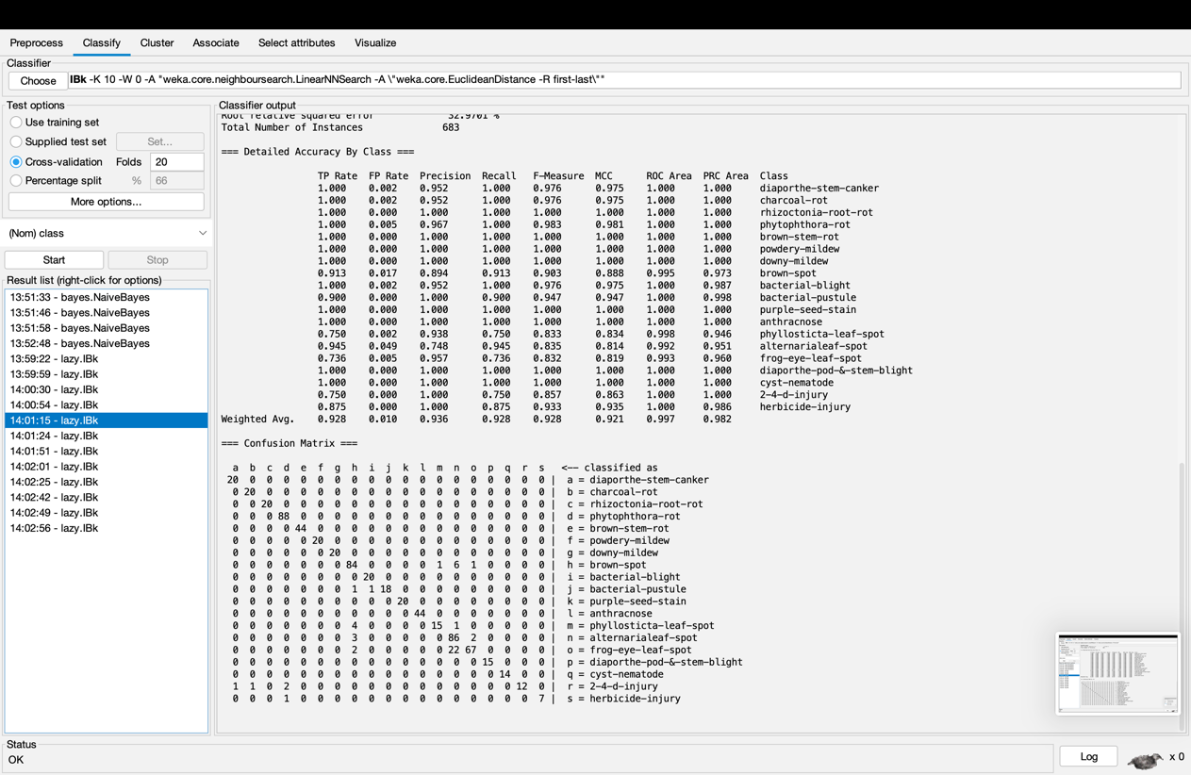

IBk with k-value = 10

Using Cross-validation folds = 10

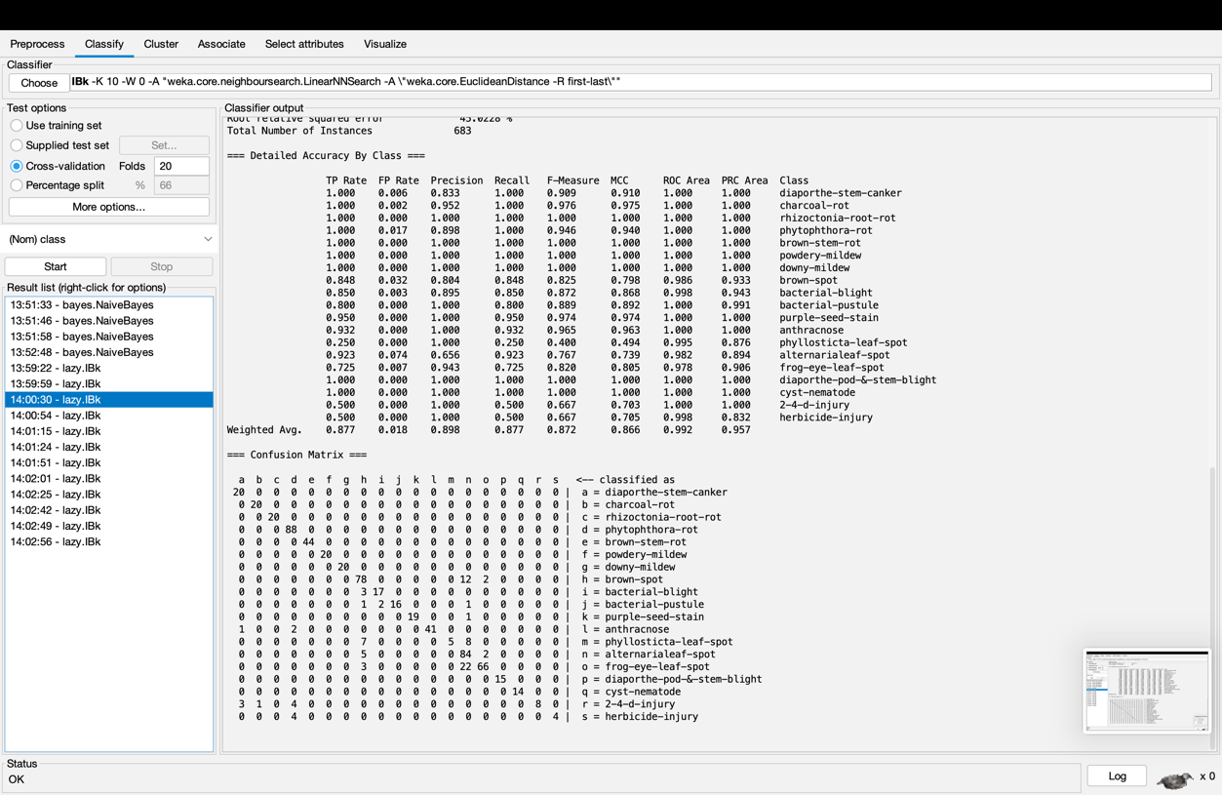

Using Cross-validation folds = 5

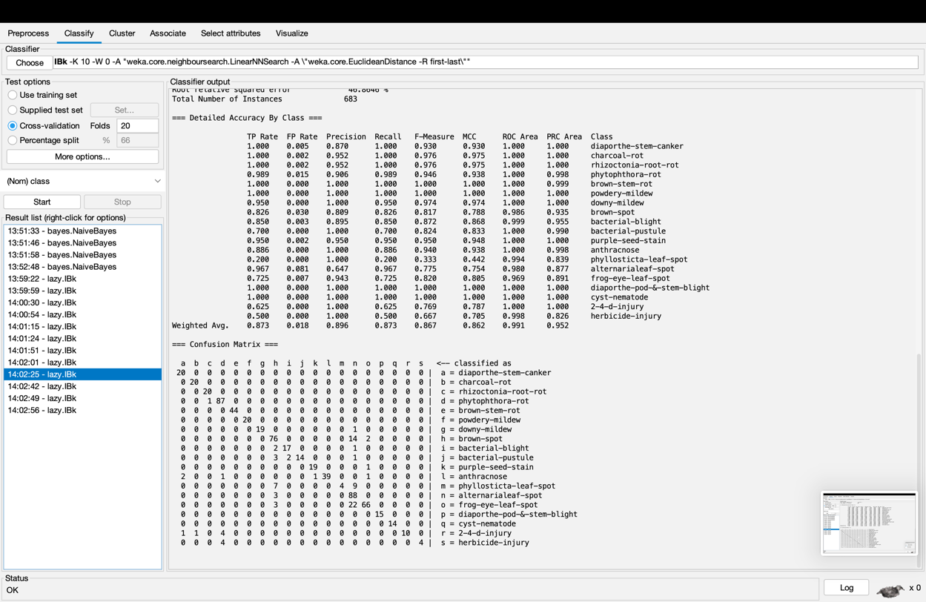

Using Cross-validation folds = 20

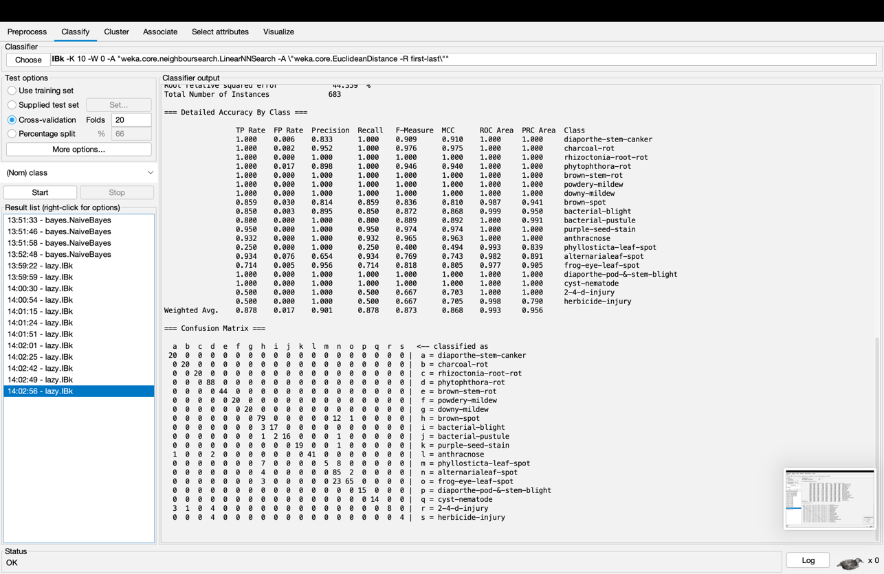

Using training set

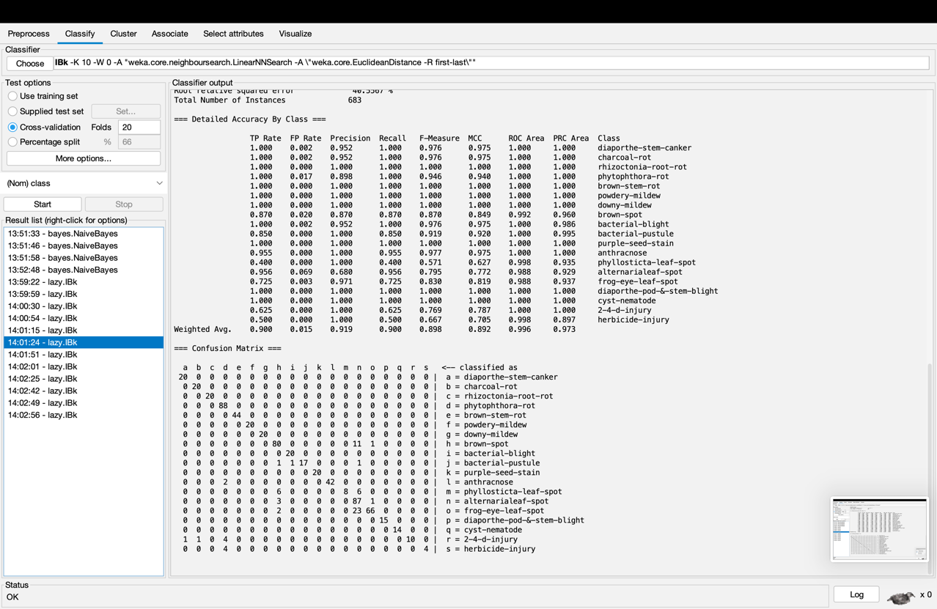

IBk with distance Function of nearestNeighbourSearchAlgorithm = Manhattan Distance

Using Cross-validation folds = 10

IBk with k-value = 1

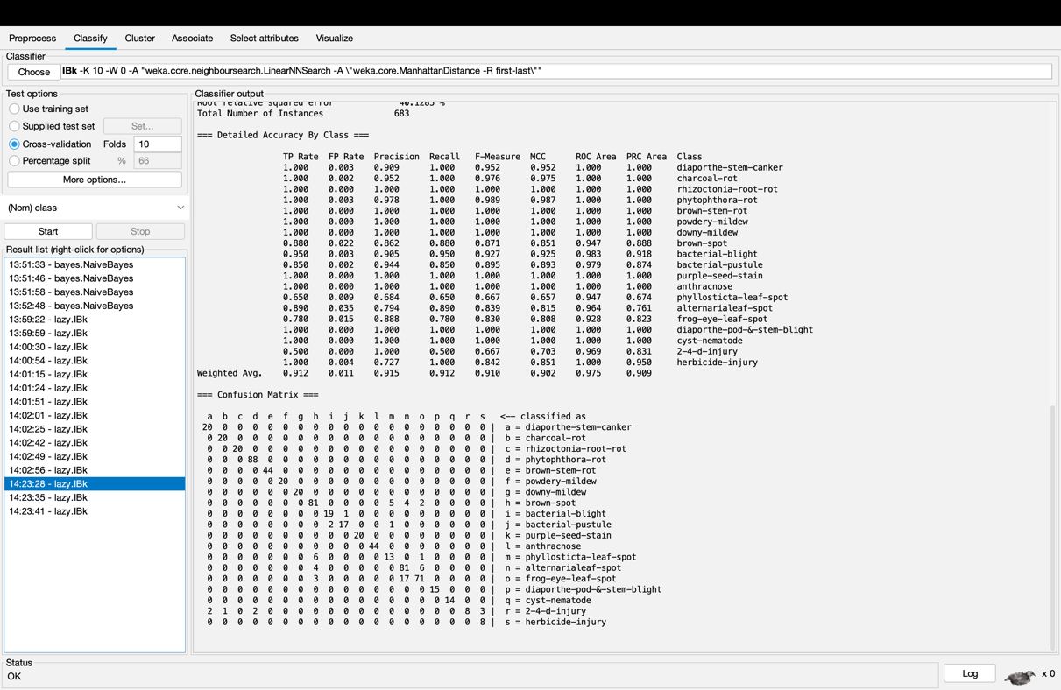

IBk with k-value = 5

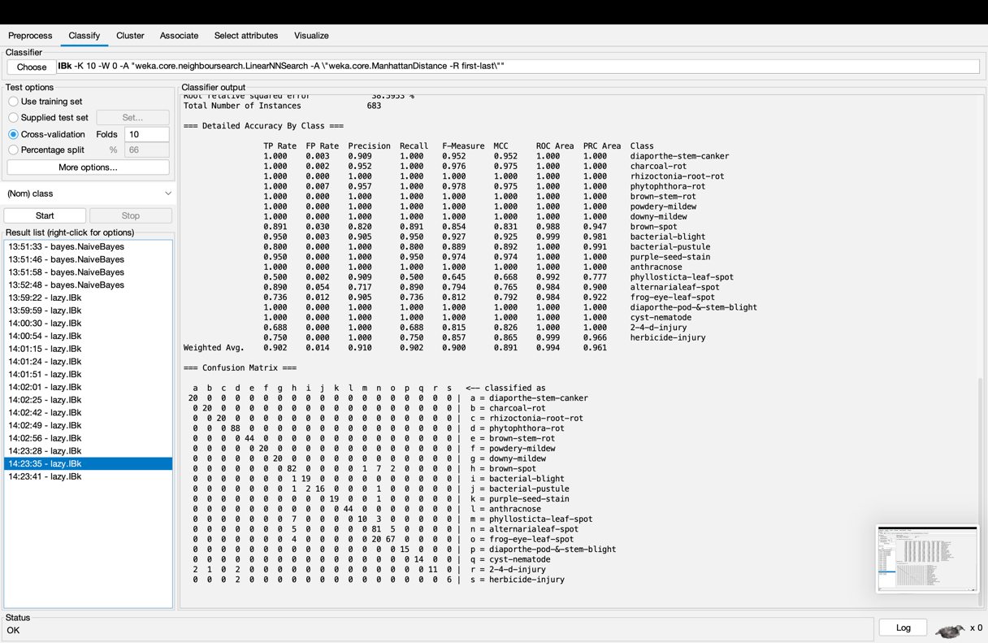

IBk with k-value = 10

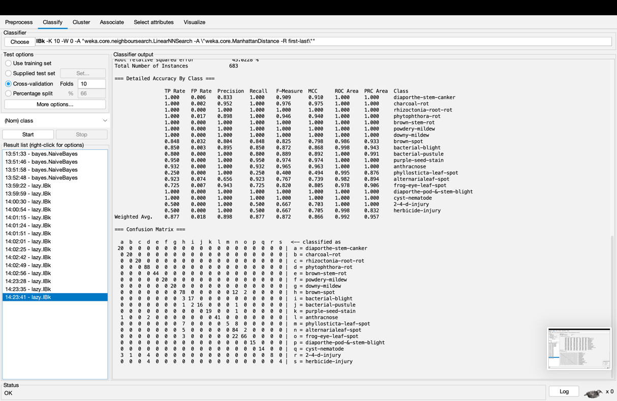

1. JRip;

Using Cross-validation folds = 10

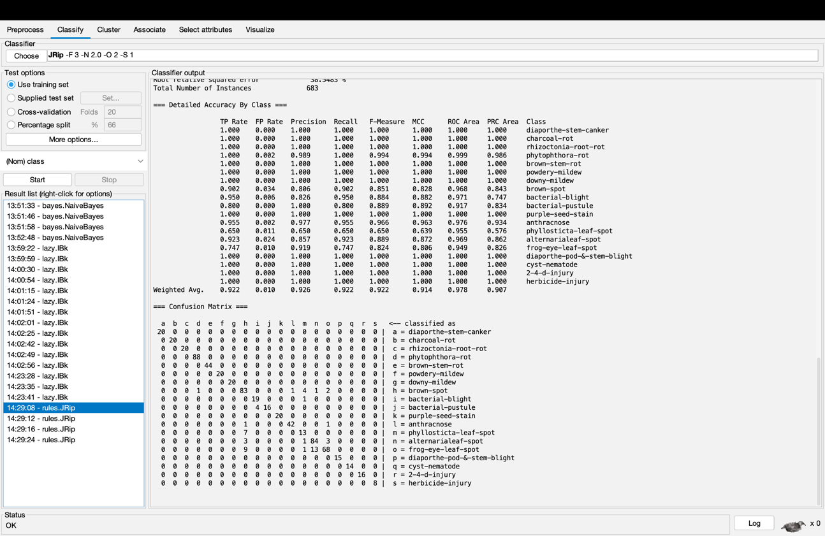

Using Cross-validation folds = 5

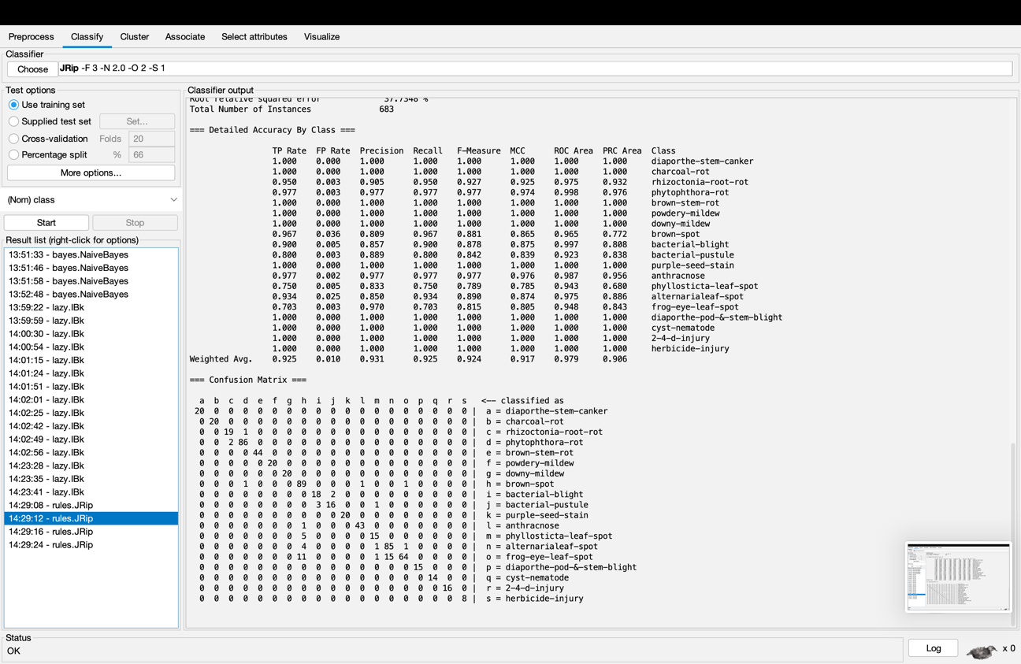

Using Cross-validation folds = 20

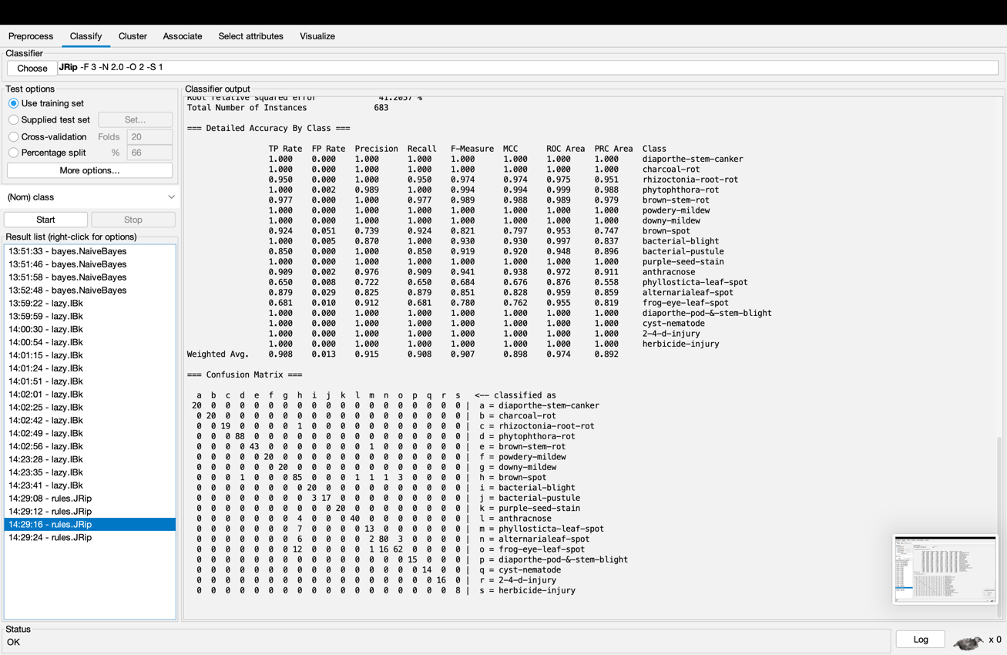

Using training set

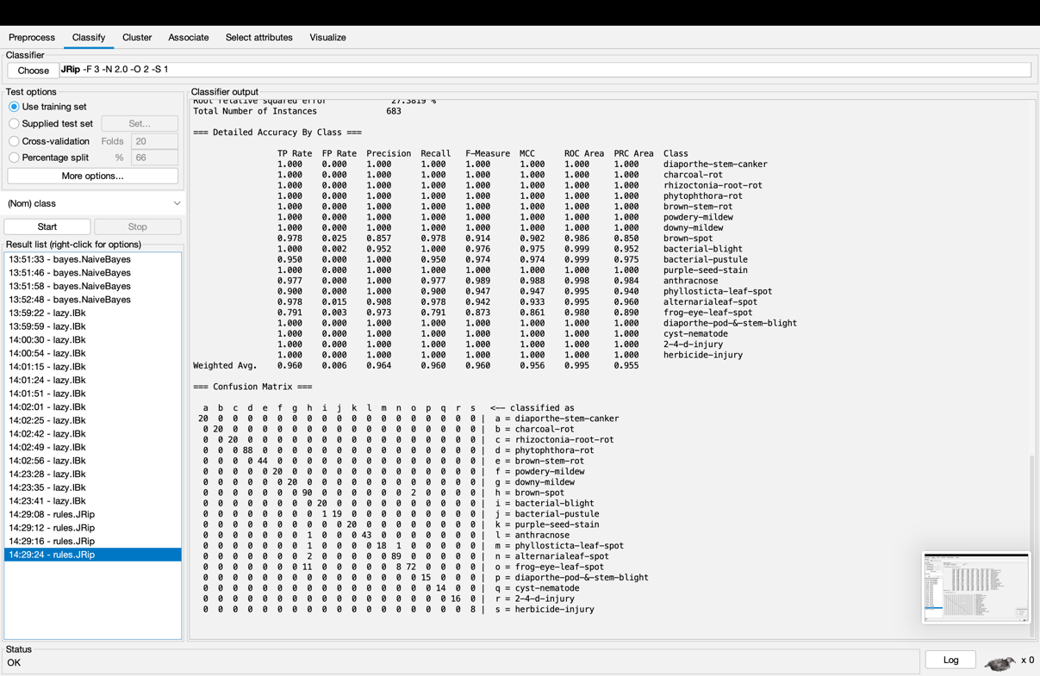

1. MultilayerPerceptron

Using Cross-validation folds = 2

Hidden Layers = a

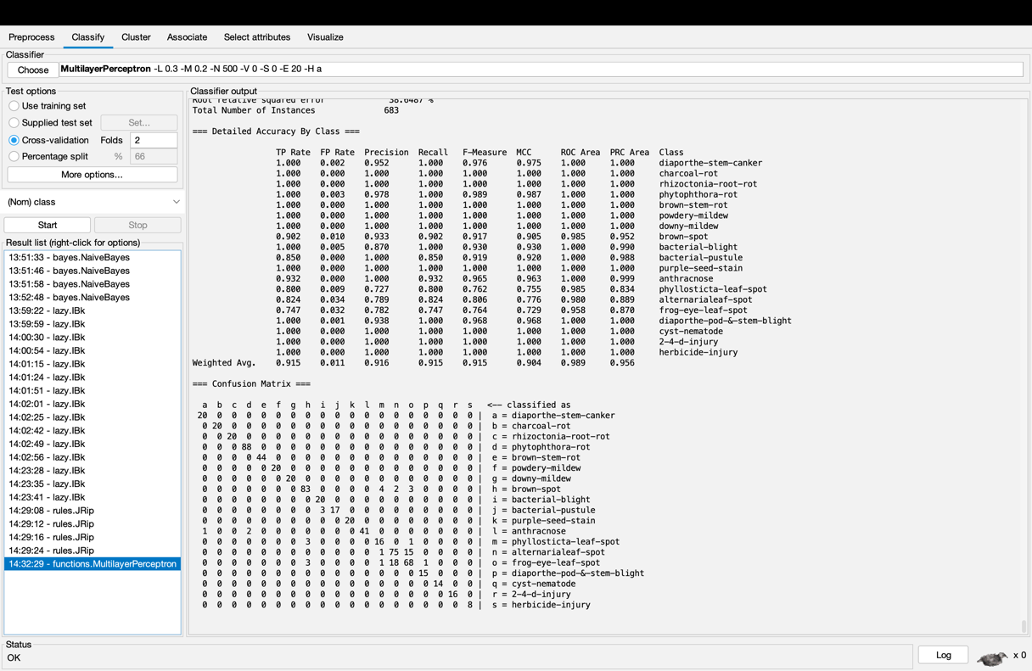

Hidden Layers = 2

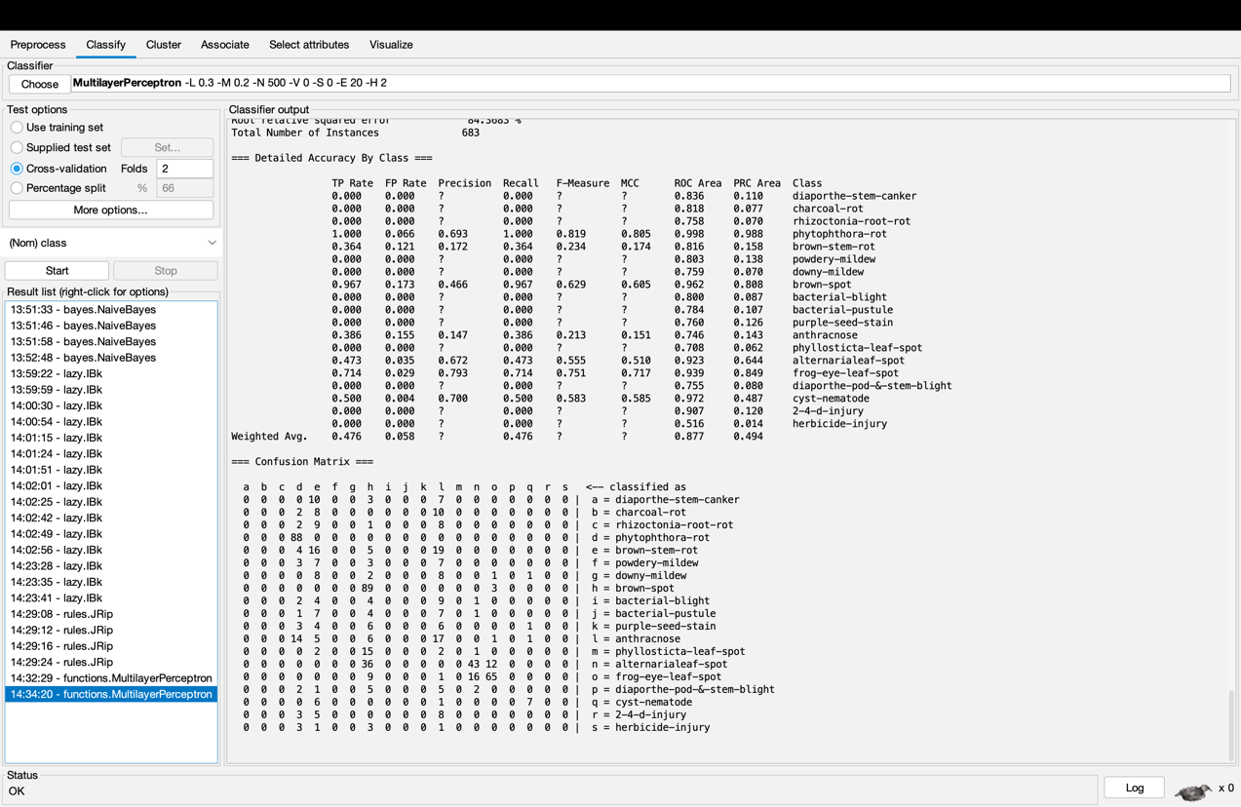

Using Cross-validation folds = 5

Hidden Layers = a

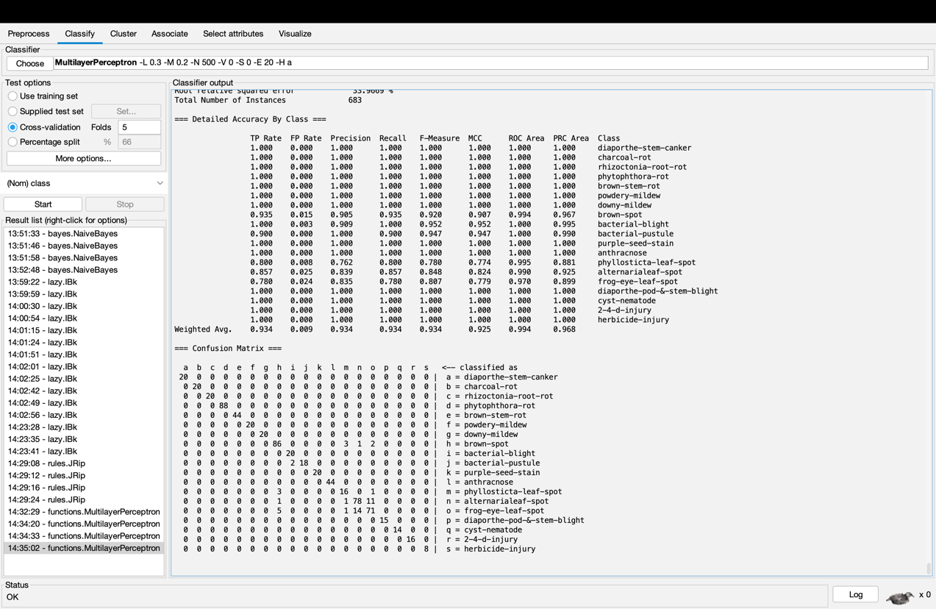

Hidden Layers = 2

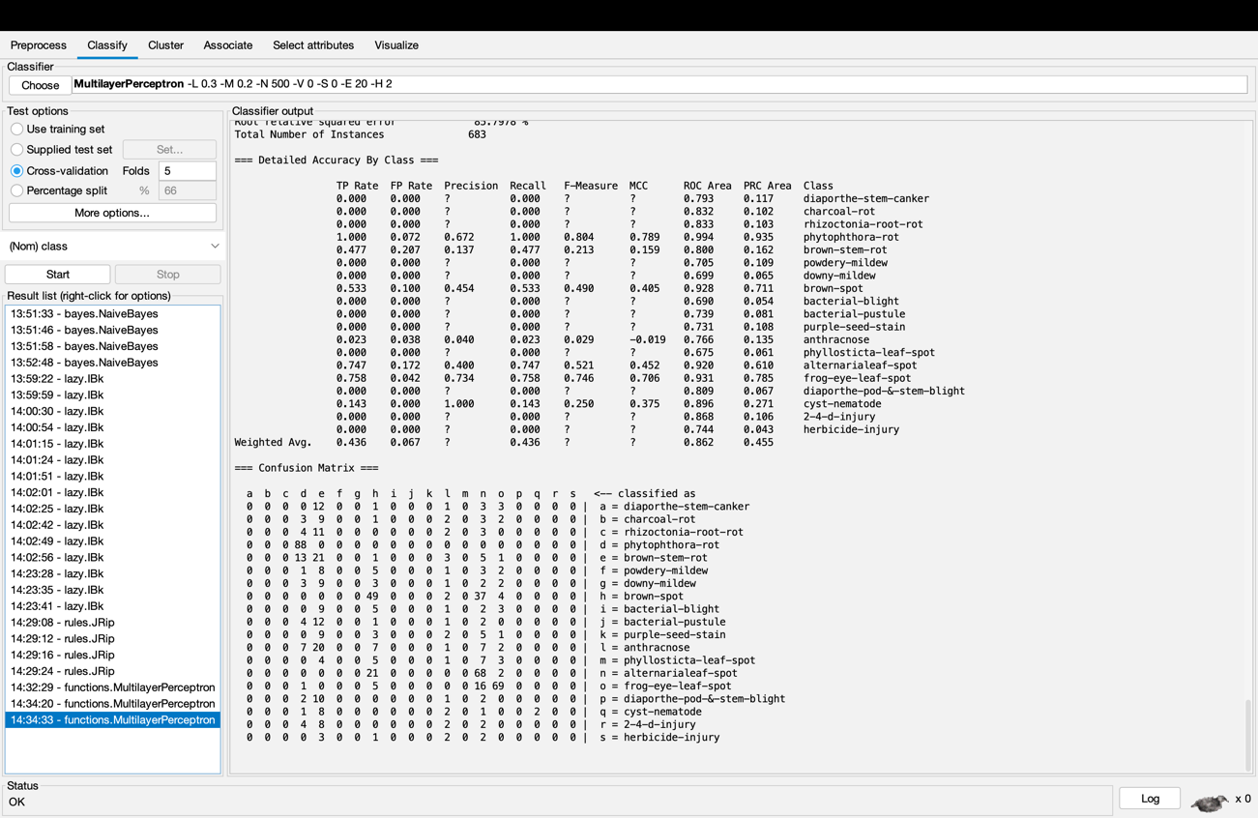

**\*\*\*\*\*\*\*\*\*\*\*\*\* Task for submission \*\*\*\*\*\*\*\*\*\*\*\*\*\*\*\*\*\*\*\*\*\*\*\*\*\*\*\*\*\*\*\*\***

Screen capture each classification result in Weka and include in your document to submit.

**\*\*\*\*\*\*\*\*\*\*\*\*\*\*\*\*\*\*\*\*\*\*\*\*\*\*\*\*\*\*\*\*\*\*\*\*\*\*\*\*\*\*\*\*\*\*\*\*\*\*\*\*\*\*\*\*\*\*\*\*\*\*\*\*\*\*\***

**[Task 2]**

In Weka, perform an experiment that compares the performance (in terms of accuracy level) of the classification algorithms mentioned in [Task 1] against that of J48 over the data set in soybean.arff. Observe and explain the analysis results. The experiment may take some time because the involvement of the MultilayerPerceptron algorithm.

I did an experiment with NaiveBayes, IBk with Euclidean Distance, IBk with Manhattan Distance, JRip, Multilayer Perceptron with hidden layer ‘a’, J48 and Multilayer Perceptron with hidden layer ‘5’ on number of folds equals to 3.

This is the result after analysing the experiment and performing the test.

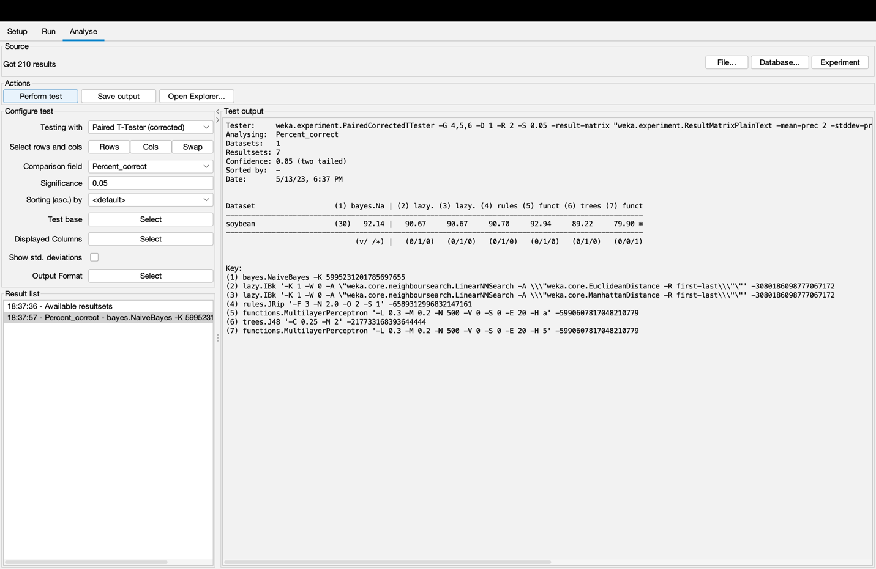

The result shows the biggest accuracy to Multilayer Perceptron with hidden layer ‘a’ with 92.94 follows by NavieBayes with 92.14. I think this is due to the complexity of the soybean.arff. Multilayer Perception Algorithm can handle well with complex data set due to its ability to comprehend non-linear relationship. Same goes for NaiveBayes algorithm is good at handling complex data set. IBk and JRip algorithms have nearly same accuracy. It is due to how both algorithms handle the data set. The performance and how they handle a data set is nearly common. But when it comes to Multilayer Perceptron with hidden layer ‘5’ gets the lowest accuracy. This can be due to the fact that the value of hidden layer is too low or too high or should not be included. The result of the J48 algorithm is kind of low. This is also explainable. This is cause by the complexity of the data set. The algorithm J48 try to put out a tree based on the data. Therefore, if the data gone missing, the accuracy of the algorithm gets low. If the data is messed up, the accuracy of the algorithm gets low.

**\*\*\*\*\*\*\*\*\*\*\*\*\* Task for submission \*\*\*\*\*\*\*\*\*\*\*\*\*\*\*\*\*\*\*\*\*\*\*\*\*\*\*\*\*\*\*\*\***

Screen capture the Weka experiment analysis result to include in the document to submit, in addition to your own explanation about the analysis results.

**\*\*\*\*\*\*\*\*\*\*\*\*\*\*\*\*\*\*\*\*\*\*\*\*\*\*\*\*\*\*\*\*\*\*\*\*\*\*\*\*\*\*\*\*\*\*\*\*\*\*\*\*\*\*\*\*\*\*\*\*\*\*\*\*\*\*\***